**IMME19 Website modifications:**

**Home tab:**

**Banner: Full conference name should come in the middle. In 2nd, nd should come as superscript. NITT logo size should equal to the MME19 logo**

All the about details to be modified as per our recent brochure content. Check the superscripts! Keep justified alignment for all descriptions in the home page.

**Keep height of the sponsorship and sponsors row smaller**

Add tourist destination’s actual images for all photos send by Dr. Sivaprasad.

Add forward/backward symbols (< >) for moving the images in tourist destinations.

**Committee tab:**

**Reduce the space for all (Patron, Chairman, etc.). We should not scroll page to look all the NITT committee members.**

**Add Dr. S. Jerome before Dr. D. Nagarajan**

**Remove the designations given for Prof. S. Natarajan, Prof. S.P. Kumaresh Babu and Dr. V. Suriyanarayanan**

• Prof. Jürgen Eckert, Erich Schmid Institute of Materials Science, Austrian Academy of Sciences (ÖAW), Austria

<https://www.oeaw.ac.at/esi/institute/staff/juergen-eckert/>

• ⦾ Prof. Eric J. Mittemeijer, Max Planck Institute for Metals Research, Stuttgart, Germany

<https://www.stuttgart.is.mpg.de/person/12478/3345>

• ⦾ Prof. Ruslan Z Valiev, Ufa State Aviation Technical University, Russia

<http://www.ipam.ugatu.ac.ru/people/valiev.html>

• ⦾ Prof. Fillippo Berto, NTNU, Norway

<https://www.ntnu.edu/employees/filippo.berto>

• ⦾ Prof. Woo-Seong Che, Kyungsung University, South Korea

• ⦾ Prof. Honggang Dong, Dalian University of Technology, P R China

<http://faculty.dlut.edu.cn/Dong_Honggang/en/index.htm>

• ⦾ Prof. Marc Leparoux, EMPA, Switzerland

<https://www.empa.ch/web/s204/marc-leparoux>

• ⦾ Prof. K. Prasad Rao, University of Neveda, Reno, USA

<https://www.unr.edu/cme/people/kalvala>

• ⦾ Prof. K. G. Prashanth, Tallinn University, Estonia

<https://www.etis.ee/CV/Prashanth_Konda%20Gokuldoss/eng?lang=ENG>

• ⦾ Prof. Evgeny Parfenov, Ufa State Aviation Technical University, Russia

• ⦾ Prof. Carlos H. Cáceres, The University of Queensland, Australia

• ⦾ Prof. Peng Li, Dalian University of Technology, P R China

**Carefully change the designations of the professors once again.**

• Dr. K. Muraleedharan, Director, CSIR-CGCRI, Kolkata

<http://www.cgcri.res.in/page.php?id=502>

• ⦾ Dr. G. Madhusudhan Reddy, Associate Director, DMRL, Hyderabad

<https://www.researchgate.net/profile/G_Reddy2>

• ⦾ Prof. K. Bhanushankar Rao, Pratt-Whitney Chair Professor, University of Hyderabad

<https://www.uohyd.ac.in/index.php/admissions/156-academics/schools-of-study/school-of-engineering-sciences-and-technology/522-kbs-rao>

• ⦾ Mr. V. Srinivasa Chandra, Assistant General Manager, Ashok Leyland, Chennai

<https://www.linkedin.com/in/srinivasa-chandra-v-82875a24/?originalSubdomain=in>

• ⦾ Prof. B. S. Murty, Institute Professor, IIT Madras, Chennai

<https://mme.iitm.ac.in/murty/bsmurty>

• ⦾ Prof. T. A. Abinandanan, Chairman, Department of Materials Engineerng, IISc, Bengaluru

<https://materials.iisc.ac.in/~abinand/>

• ⦾ Prof. V. Balasubramanian, Director, CEMAJOR, Annamalai University, Chidambaram

<https://annamalaiuniversity.ac.in/faculty_view.php?id=02784&dc=E04>

• ⦾ Prof. D. Ravikumar, Department of Mechanical Engineering, IIT Delhi

<http://mech.iitd.ac.in/content/ravi-kumar-digavalli>

• ⦾ Dr. P. Shanmugam, Senior General Manager, Sundaram Fasteners Limited, Chennai

* Dr. Sitarameswara Sarma Akella, Senior General Manager, Mahindra and Mahindra Limited, Chennai

<https://www.linkedin.com/in/sitarameswara-sarma-akella-63898a114/?originalSubdomain=in>

**In Registration and Publication tab:**

In registration fee, remove # symbol from spouse.

In right column Guidelines: Delete “Guidelines for Abstract Submission”

There should be option to add registration link and paper submission link.

Under Publication;

All accepted papers will be published in popular SCOPUS and/or SCIE indexed journals.

The journal list will be updated soon.

Hide all the images shown now. Important dates, remove “early bird”

**In SPEAKERS tab:**

Currently put “Coming soon.”

No need of all other images now, but all should be enabled after confirmations from the speakers.

The speaker image and details should be small, all speakers (atleast 12 speakers) details should be visible in the same page itself.

Remove the 12 publications, 30 themes, etc. in the right column

**In CONTACT tab:**

Contact info: Change as per our Brochure

**In IMME17 tab:**

Add the banner of IMME17 in top banner image

Add the following as “Glimpses of IMME17

International Conference on Emerging Trends in Materials and Manufacturing Engineering (IMME17) was the first in its series of conference on the theme of new generation materials and advanced manufacturing engineering methods. Department of Metallurgical and Materials Engineering, National Institute of Technology, Tiruchirappalli has initiated this prestigious biennial series of conference with an objective of disseminating the knowledge on advancements in materials and manufacturing disciplines under the banner of Department’s Golden Jubilee year celebrations. IMME17 has witnessed an international gathering of scholars, scientists and practicing engineers to present and listen on the themed topics. This event was held for three days, from 10th to 12th March, 2017 in the Hotel Breeze Residency, Tiruchirappalli, Tamil Nadu, India. IMME17 has received significant contribution both from the academia and industry. The conference was inaugurated by Prof. Gopalan Srinivasan of Oakland University, USA and Prof. Mustafizur Rahman of National University of Singapore followed by their plenary speeches. In addition, more than 15 key note and invited lectures was delivered by the eminent personalities from various countries like Germany, Denmark, Japan, Singapore, Malaysia, Austria and India. Though, there was overwhelming response in receiving the research contributions from the researchers across the globe and the received abstracts were more than 1000, only 320 contributions have been selected for the presentation in the conference. Among them, only 257 papers are considered for the publication in after a thorough peer review process. The articles were published in Transactions of Indian Institute of Metals and Materials Today: Proceedings.

Add the following images (the images were sent to you by Dr. Sivaprasad on April 2) with corresponding links

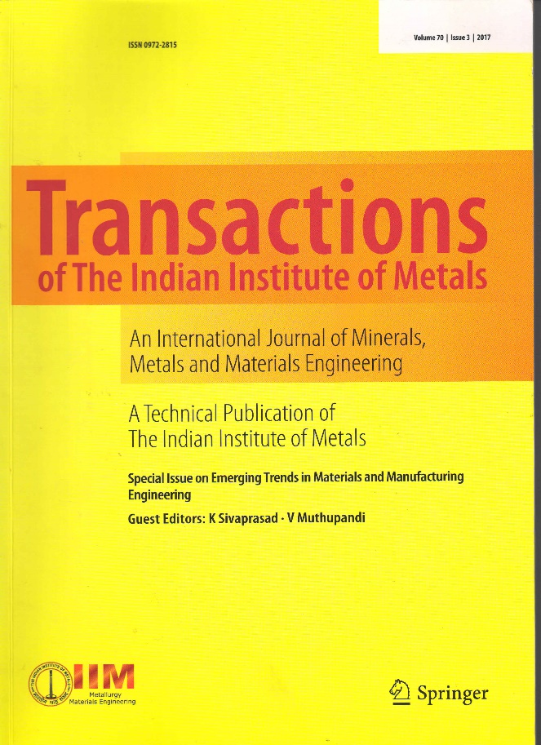

<https://link.springer.com/journal/12666/70/3/page/1>

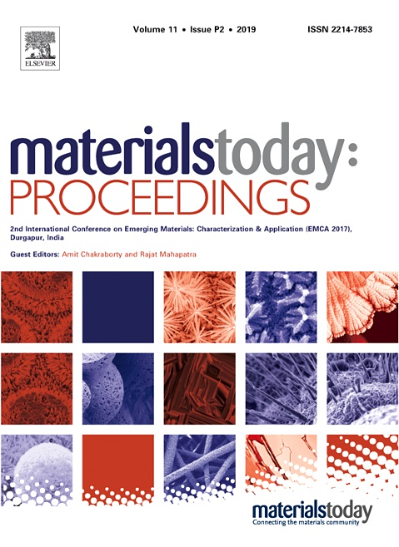

<https://www.sciencedirect.com/journal/materials-today-proceedings/vol/5/issue/2/part/P2>

Conference Souvenir

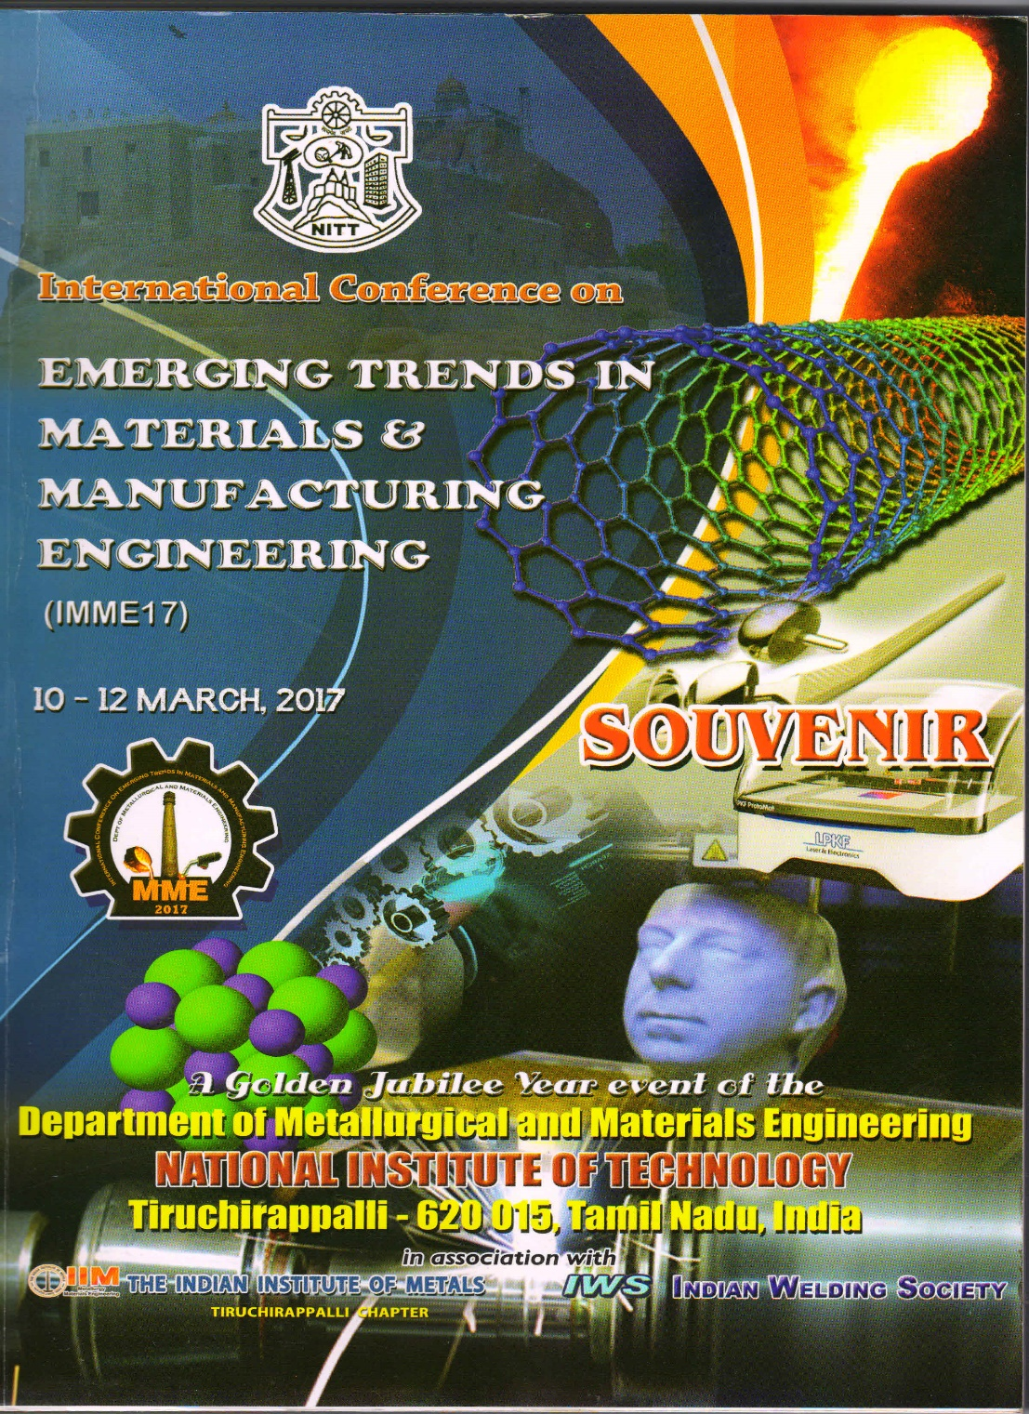

Remove Right column details in IMME17 tab.